**USER MANUAL**

**IDENTIFYING ACCIDENT HOTSPOTS USING SPATIAL DATA**

Submitted By

Rhythm Malhotra 16103156

Shreyas Jain 16103200

Shruti Pandey 16103230

**INSTALLATIONS:**

All the codes of our project have been written in the language Python. To run the project, hence, it’s essential to have the following tools installed:

* Python (Version 3.7 or above)

Python can be easily installed by a link present on the downloads page on the official python website ( <https://www.python.org/downloads/>) by navigating to the suitable operating system settings of your system.

Dependency libraries(along with terminal commands to install them):

* Numpy (command: pip install numpy)
* Pandas (command: pip install pandas)
* Geopandas (command: pip install geopandas)
* Shapely (command: pip install shapely)
* functools32 (command: pip install python-functools32)
* Pyproj (command: pip install python-pyproj)
* Scikit-learn (command: pip install -U scikit-learn)
* Mplleaflet(command: pip install mplleaflet)
* Plotly(command: pip install plotly)
* Matplotlib( command: python -m pip install -U matplotlib)

Dependencies imported in our project.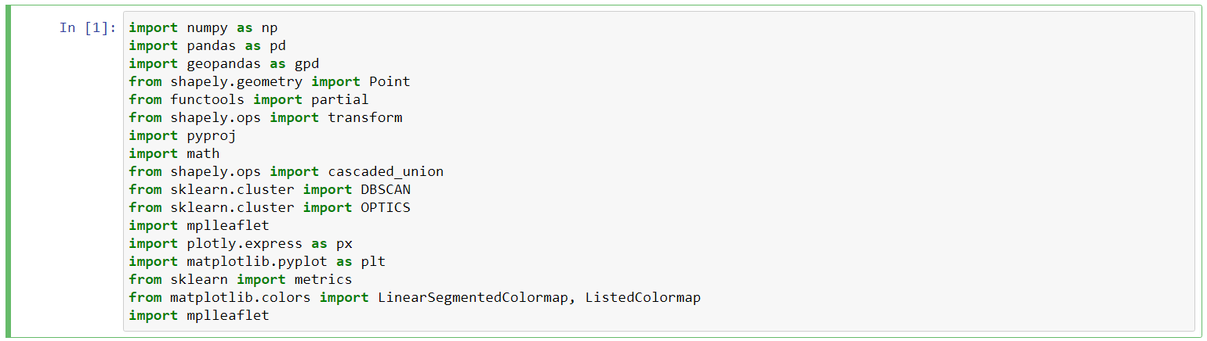

**Running the scripts:**

After having installed all the required dependencies, there are multiple ways to run the python scripts in our project.

1. **Command Line**

To run a Python script stored in a ‘.py’ file in the command line, we have to write ‘python’ keyword before the file name in the command prompt.

Command: Python dbscan.py

1. **Text Editor (VS Code)**

To run Python script on a text editor, a python editor needs to be installed. Some of the popular editors are:

* Jupyter Notebook
* VS Code (Visual Studio Code)
* Sublime Text
* Atom
* Vim

For editing our project, we used the Jupyter Notebook

**JUPYTER NOTEBOOK**

The Jupyter Notebook is an open-source web application that you can use to create and share documents that contain live code, equations, visualizations, and text. This tool can be used with several programming languages, including Python, Julia, R, Haskell, and Ruby. It is often used for working with data, statistical modeling, and machine learning.

* Before starting with the Jupyter notebook, you should have the proper version of python installed. We have used Python3.7.
* Then we have to install Jupyter. To get started, you need to open up your terminal and run Jupyter notebook using the following command:

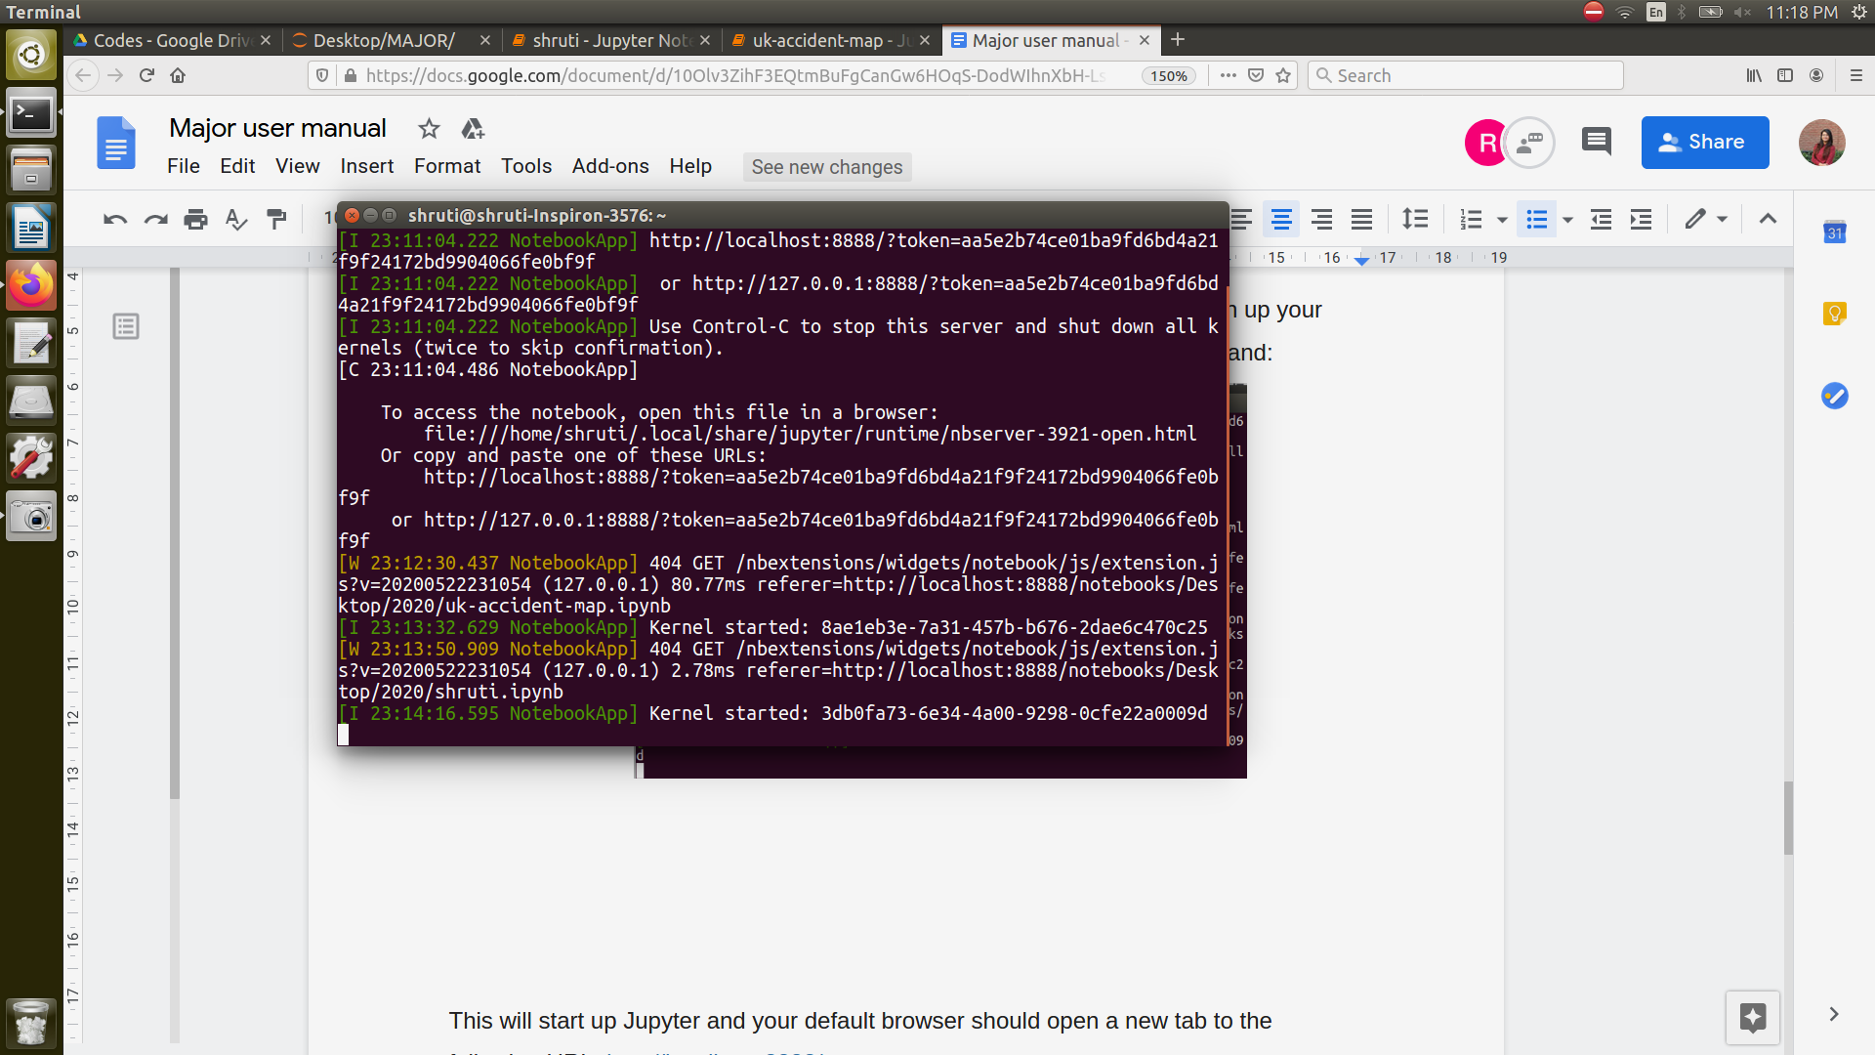

This will start up Jupyter and your default browser should open a new tab to the following URL: <http://localhost:8888/tree>

Your browser should now look something like this:

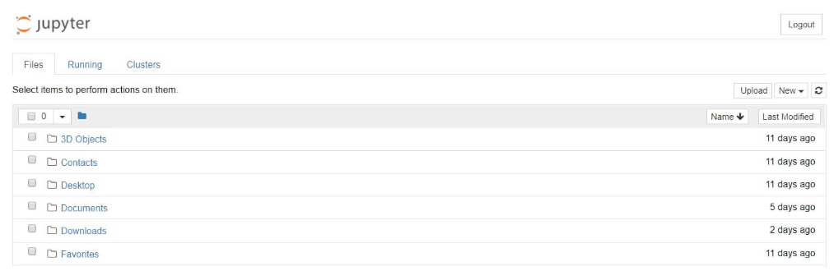

* Browse through the directory where your code is saved and run the code.

**RUNNING THE CODE ON JUPYTER NOTEBOOK**

Once you have opened the code on the Jupyter Notebook, you may use various options to run the code.

* Managing the Kernel

The code is run in a separate process called the Kernel. The Kernel can be interrupted or restarted from the kernel option in the menu bar.

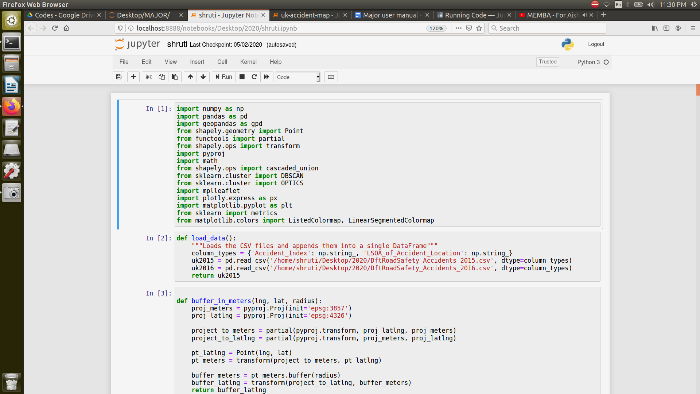

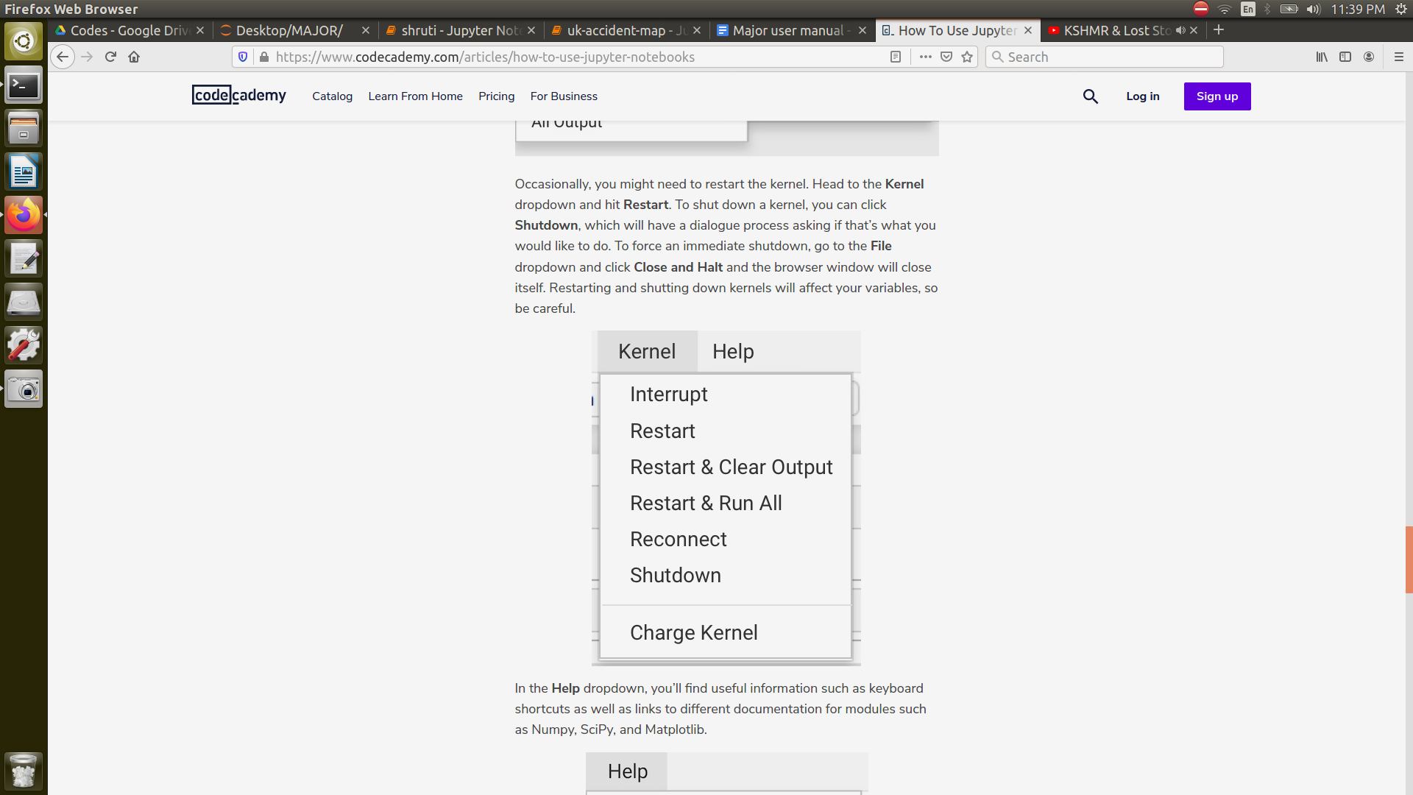

* Cell menu

The “Cell” menu has a number of menu items for running code in different ways. These includes:

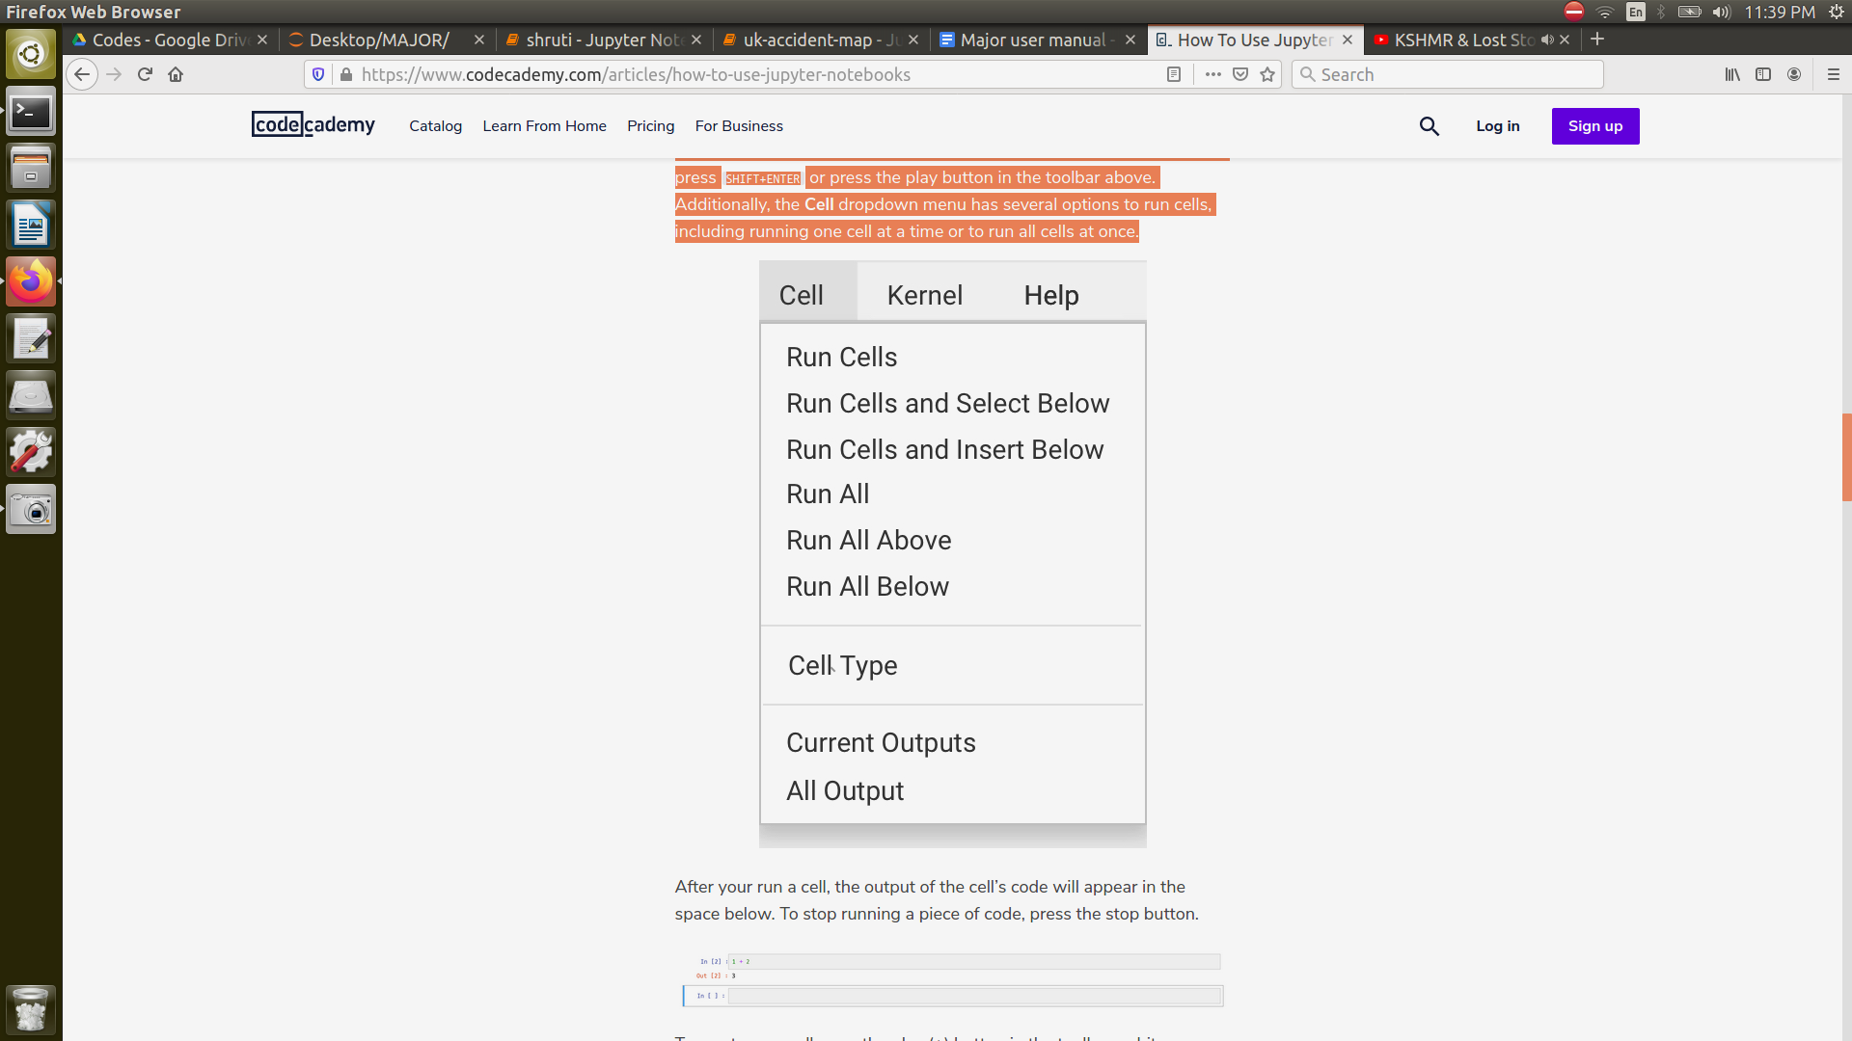

1. **IDE (PyCharm)**

Python scripts can also run on an IDE (Integrated Development Environment). Some of the most popular Python IDEs are:

* PyCharm
* Spyder
* PyDev
* IDLE

To run the project on PyCharm, you will have to **Right-click** and select the ‘**Run File in Python Console**’ option. This will open a console box at the bottom and show the output there. We can also run using the **Green Play Button** at the top right corner of the IDE.

We have two codes, one for DBSCAN and OPTICS each. Each code needs to be run separately. The codes take a lot of time to run, around 5-6 hours each as each has 1000 iterations of clustering of the huge data.